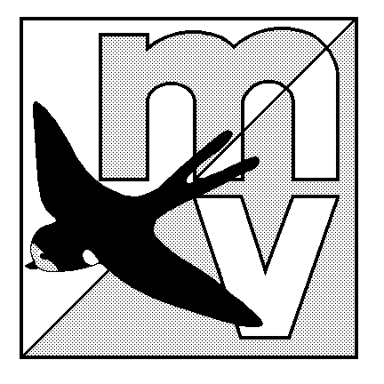
MOLE VALLEY

ORIENTEERING

CLUB

RESULTS OF THE SHEEPLEAS LOCAL EVENT HELD ON 11th NOVEMBER

YELLOW COURSE
2.1 km, 55m climb

1 Simon Hanson TYM 26.00
2 Emma Southwell TYM 41.21
3 Chris E TYM 46.05
4 Moss family TYM 58.15

ORANGE COURSE
2.9 km, 95m climb

1 Andrew Wells M35 IND 41.06
2 Harri Melhuish M16 TYM 52.40
3 Luke Brown TYM 59.41
4 Carla & Lou W17 TYM 71.08
5 Shrimpton M10/W45 MV 104.15
6 A Shrimpton M14 MV 112.37
7 Lewis Caprindale M16 MV retired

GREEN COURSE
4.7 km, 125m climb

1 Ian Ditchfield M45 MV 38.01
2 Belinda Bryan W21 MV 60.20
3 M Cheesman M21 MV 62.07
4 David Fisher M45 MV 63.25
5 Maurice Dunnett M55 MV 65.36
6 Simon Ling M55 MV 69.02
7 John Smewing M45 MV 70.51
8 Dave Spragg M21 IND 71.39
9 Sandra Vogel W35 MV 73.24
10 W Alexander M55 IND 77.28
11 A Fisher M45 MV 85.36
12 Michael Turner M70 MV 103.57
Philip Winn MV missed 9, 11
Hugh Walker MV missed 3, 4, 5
P Crisp W50 MV retired
Pat Nelson M70 MV retired
Michael White M60 MV retired

Thanks for coming along on what was a fairly wild morning, and I hope you enjoyed your courses.
Thanks also for comments made during and after the event, which were most helpful, and a big thank you to those Mole Valley members who helped out, or offered help.
The next local MV event is at Ranmore Common near Dorking, on 7 January. If you can’t wait that long, Guildford Orienteers have an event at St Martha’s, Guildford, on 26 November.
Enjoy your orienteering. Jon Coles

